**Assignment 6.3**

**Problem 1:** Find the number of GoogleKnowlege_Occupation people who were guests in the show, in a particular time period.  
Take the time period as 1/11/99 to 6/11/99 i.e., 6 months.

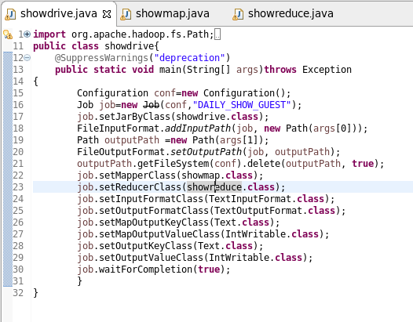

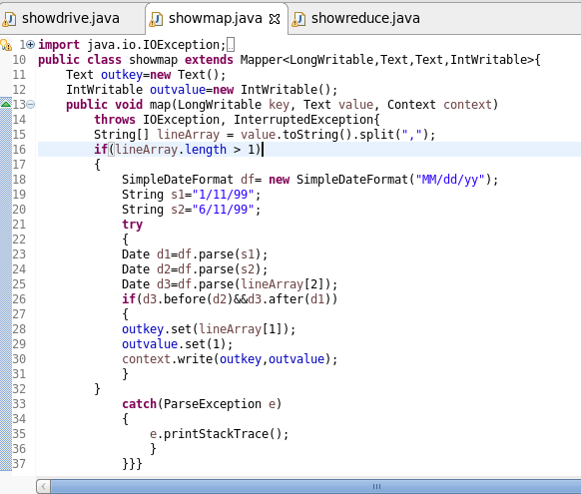

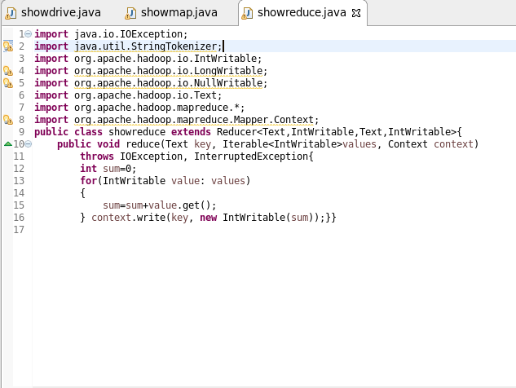

**Output:**

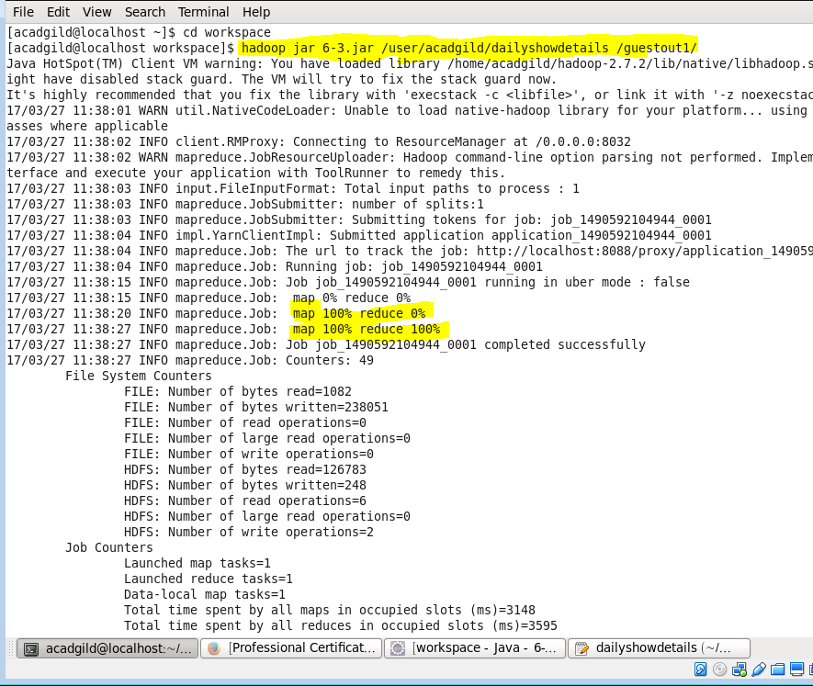

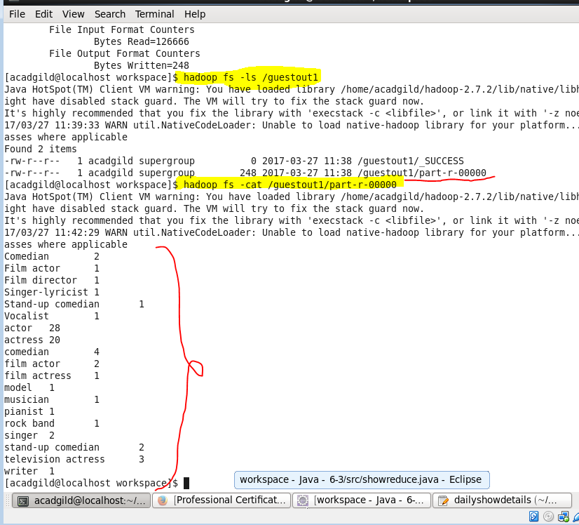

**Problem 2:** Find the number of GoogleKnowledge occupation types in each group, who have been guests on the show.



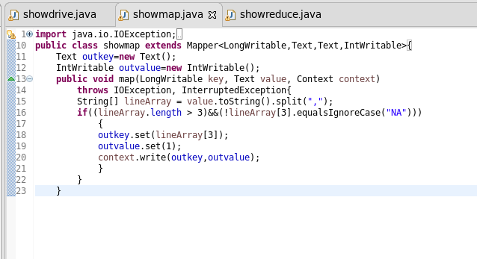



**Output:**

